**Pinkerton:**

**An evolving platformer**

In the game, Pinkerton, you simply start out as a pink pixel who has very little ability. But as you progress, so does Pinkerton. Gaining abilities and resolution along the way!

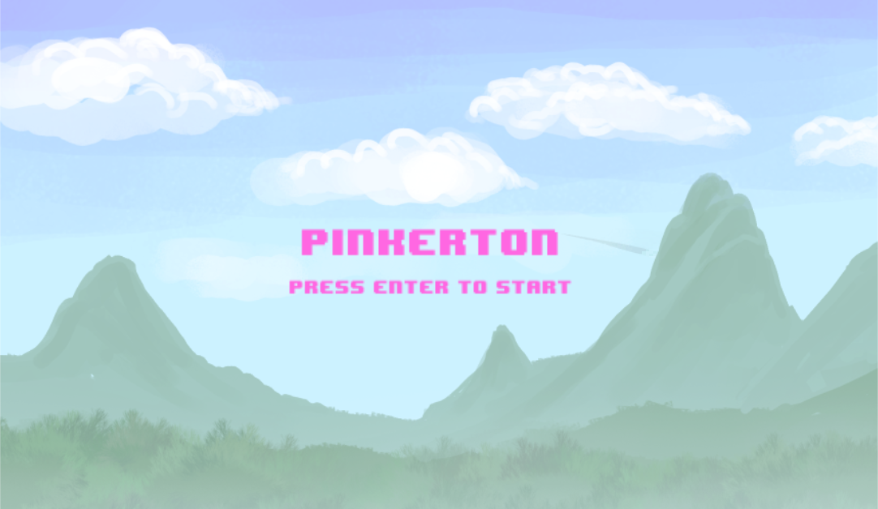

Upon opening the program, you will be greeted with this title screen. Just as the screen says, “Press Enter to Start”. When you press enter the game will begin.

If you would like to exit the game AT ANY TIME, simply close the window.

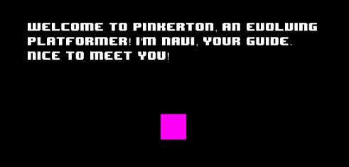

This is where the game begins. The point of the beginning is for the player to discover what needs to happen. You move with the Left  and Right  arrow keys.



You will soon come across an up arrow, this will grant you the ability to jump! Now you can make it across gaps that you would have otherwise fallen in.

Press the Spacebar  to jump!

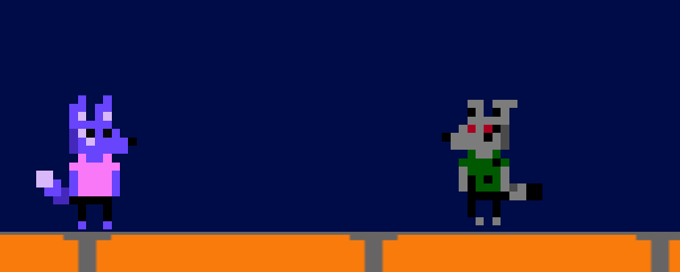

After a couple of levels you will not only get a graphical upgrade, but you will now be faced with an enemy! The evil version of you!

For now, all you will be able to do is avoid them, jump over them to get through the level.



Not only will you face enemies, but now you will see moving platforms as well. Time your jumps correctly to move from platform to platform.

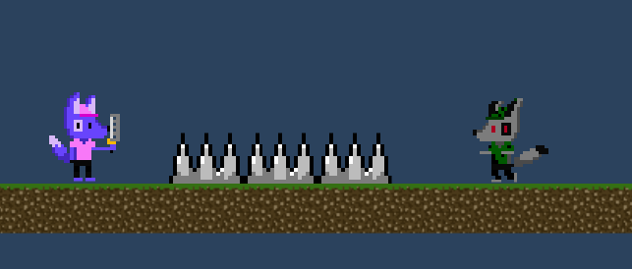

You have now gone from 8-bit to 16-bit! And now have a weapon to defend yourself against your enemies!

Press ‘F’  to attack!

You also have health now, meaning you can take a couple more hits before you die. Pinkerton has 3 hit points. And all enemies cause 1 damage.

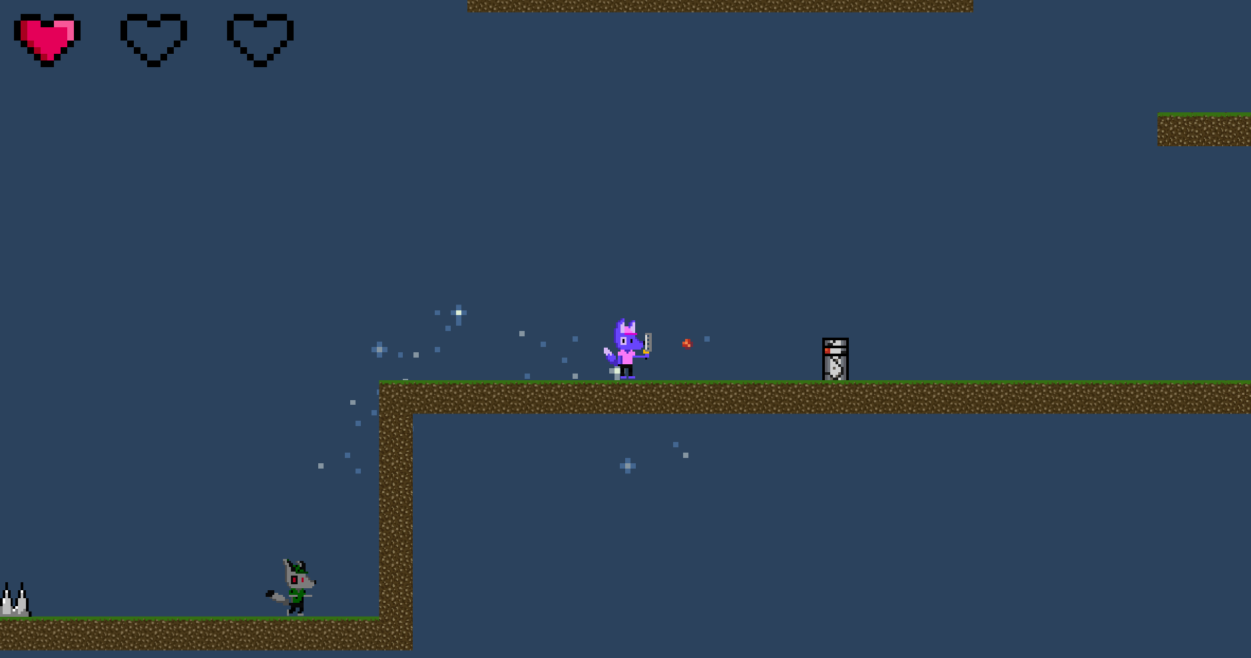

Current Pinkerton hit points shown in the top right.

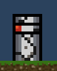 Most turrets have 2 hit points

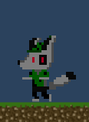 Most evil Pinkertons have 1 hit point

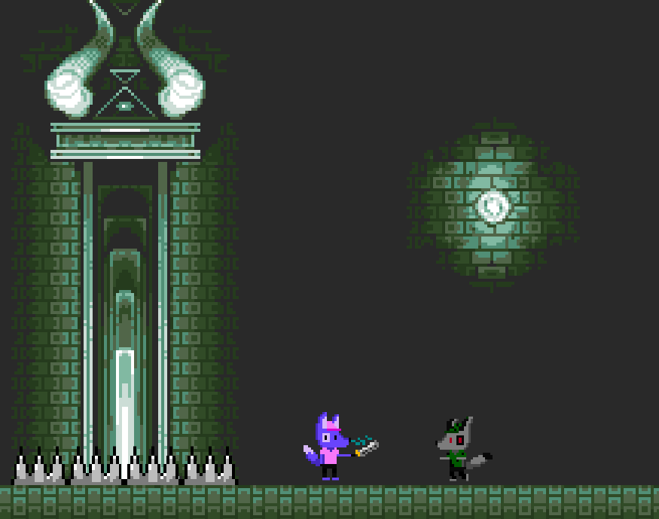

Your sword causes 1 damage to enemies.

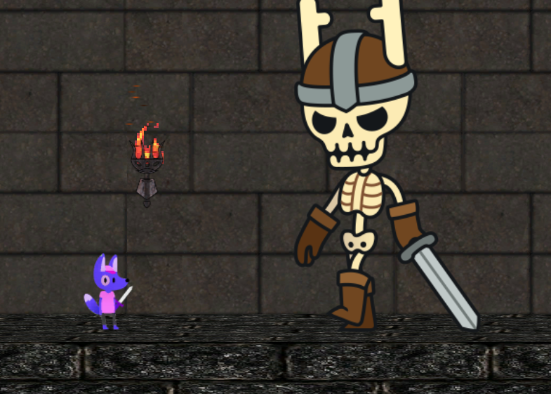

And your final upgrade comes in the form of updated graphics once more!

Scrum Masters® - Brock, Denae, and Luciano